Steps to request access to Geneva Actions – UI:

1. Go to <https://myaccess/identityiq/accessRequest/accessRequest.jsf#/accessRequestSelf/add> to request permission.
2. Search the “BG-CSS-SAW-Exception” item, as below
3. 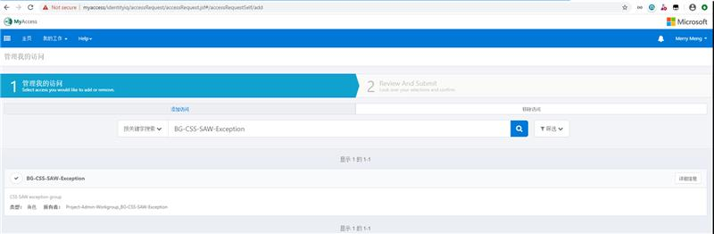
4. Click the “BG-CSS-SAW-Exception” item to choose it. Then click “Next” button.
5. 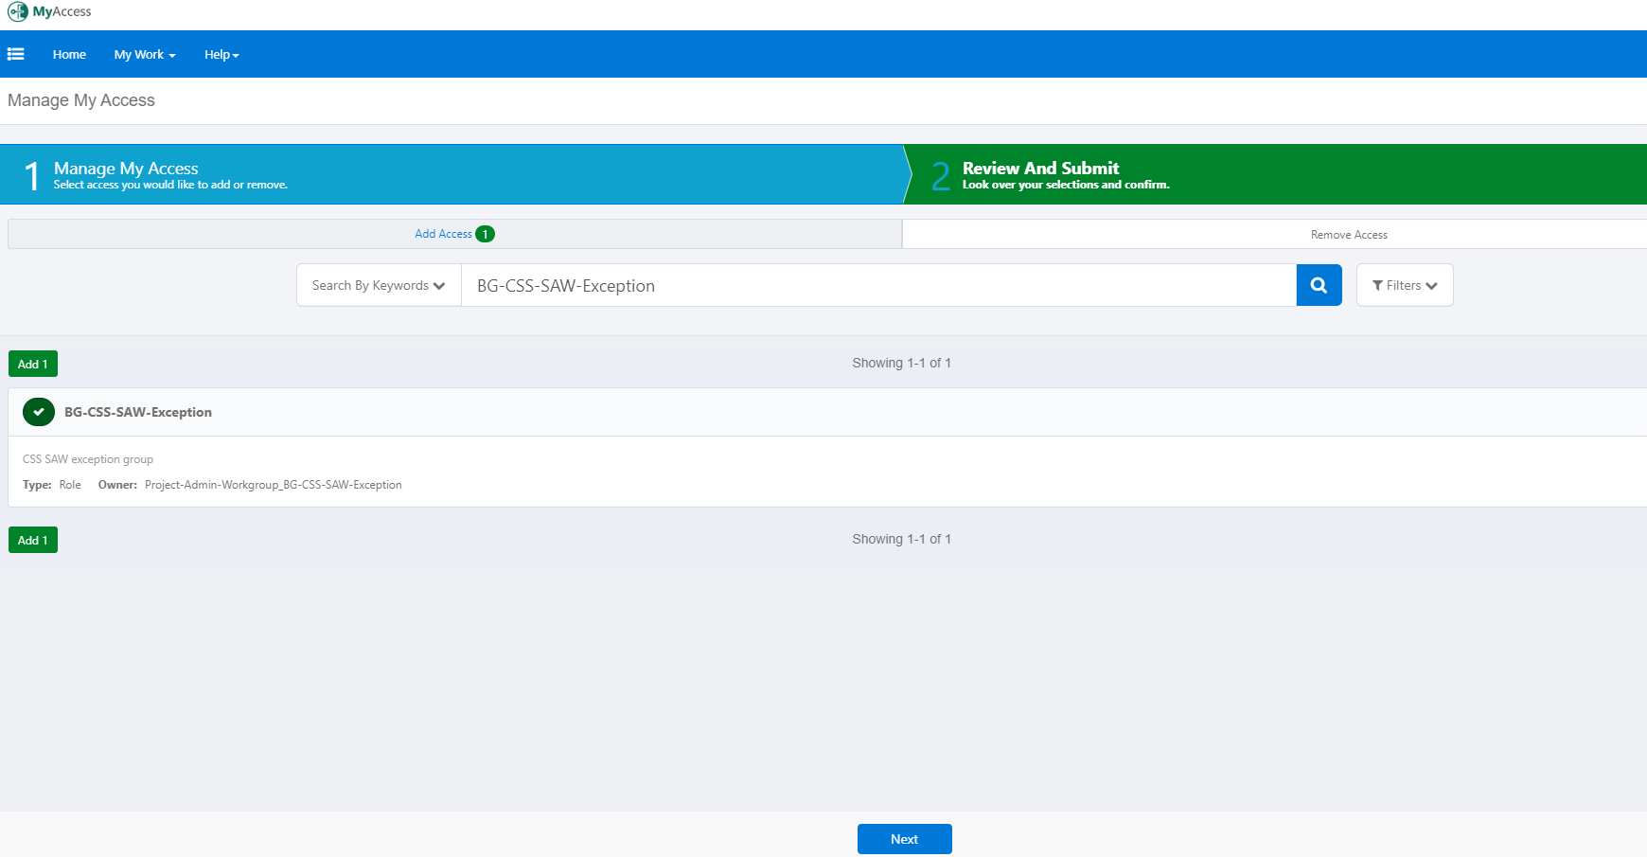
6. Click “Details” button in the top-right.
7. 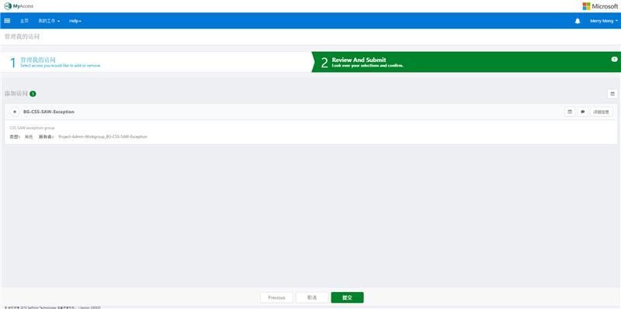
8. Configure the required settings, as below.
9. 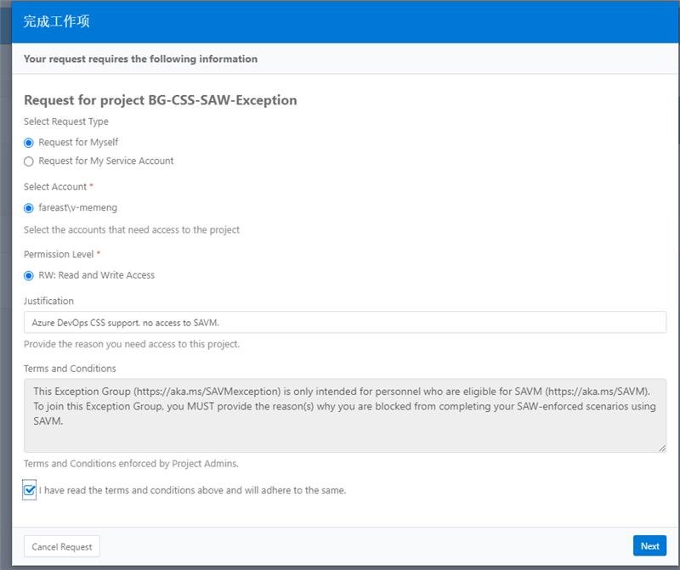
10. Fill in the Justification: Azure DevOps CSS support. no access to SAVM. Then click “Next” button.
11. 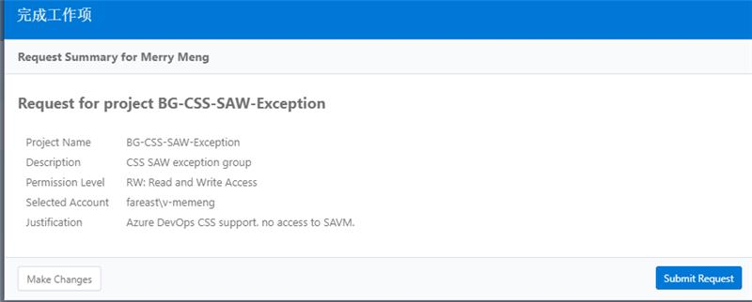
12. Click “Submit Request” button. Then it is done.
13. 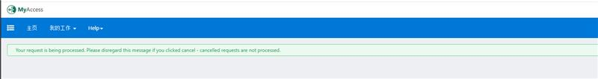
14. Search the “**TM-AzDev-CSS**” item, as below. Be sure to specify **RO:  Read Only Access** for Permission level and use this for the Justification:  “**Azure DevOps CSS Support**"
15. 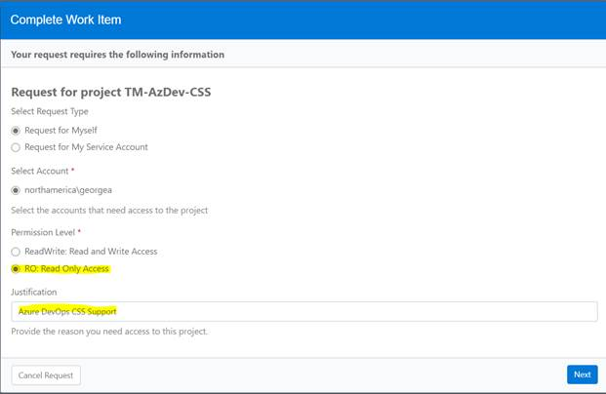
16. Click Next and then “Submit Request” button. Then it is done.
17. After your 2 permissions are granted, you could now access to use Jarvis.
18. Geneva Actions: <https://jarvis-west.dc.ad.msft.net/actions>
19. You nedd to authenticate with your Microsoft account with Smart card when firstly sign in each day.
20. 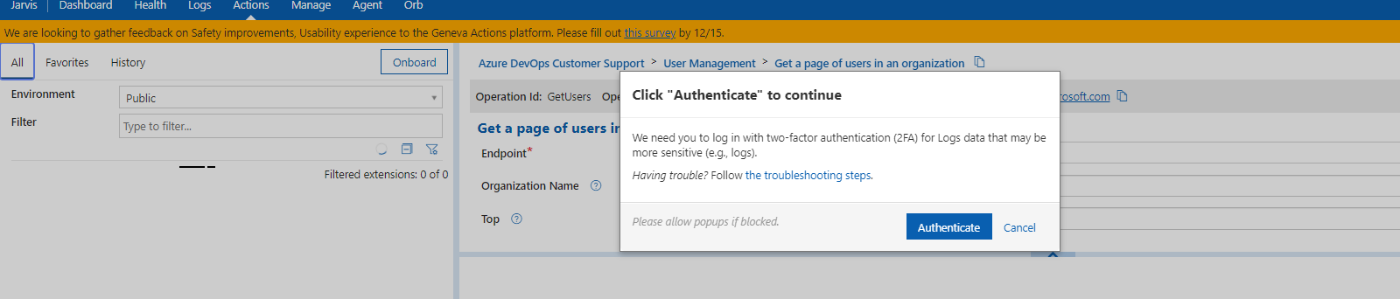
21. Click “**Get Access**” button as below.
22. 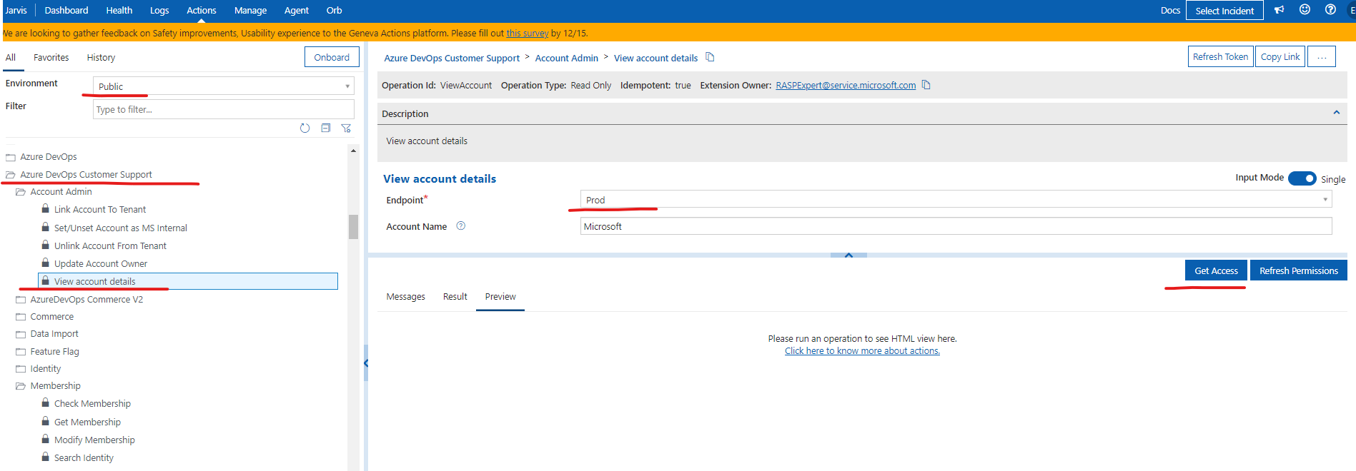
23. And then fill out using below argument.

ICM 187114109 Customer service viewer css troubleshooting

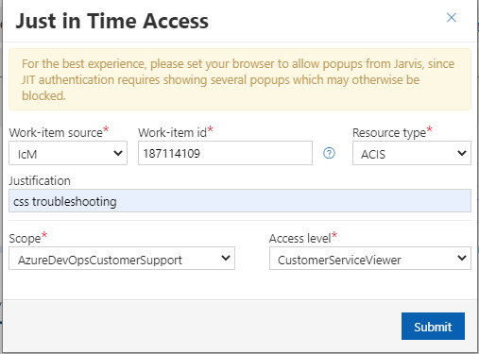

1. Click “**Submit**” to authenticate with your Microsoft account again.
2. And if you are the 1st time to use Jarvis, you may encounter below **cloudscreen** error. Please report to Jack to help complete your background investigation. After it is done, you should not see this error again.
3. 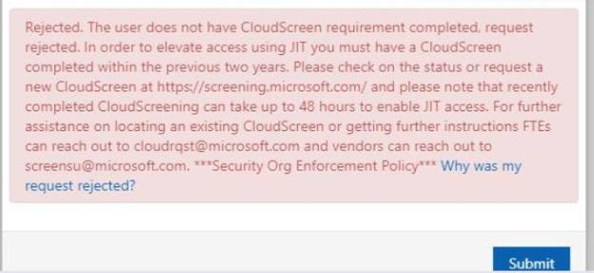
4. And then you will receive email from **Windows Azure JIT Service** [**jitpxus2@microsoft.com**](mailto:jitpxus2@microsoft.com), which says the request URL. 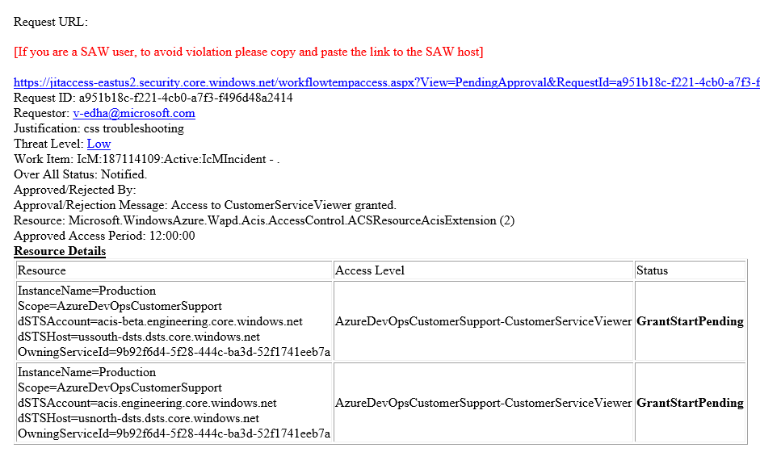
5. You could wait until someone in the approver list approves this request, or send the request url to shanghai FTE(Grace Wang, Jian-Wei Yu) via Teams to notify them to approve it.
6. After it is approved, the previous request panel will disappear, and the “**Get Access**” button become “**Run**” button. Now you could click “**Refresh permissions**” button to authenticate with your Microsoft account again.
7. Finally, after authenticating with Microsoft account 3 times totally, we can use Jarvis today, and the permission will be revoked after 24 hours. In other words, you need to request the permission each day before using it.
8. Guidance: <https://dev.azure.com/mseng/AzureDevOps/_wiki/wikis/AzureDevOps.wiki/6444/Geneva-Actions-UI>